Order Of Service

Singing: Psalm 67—CW page 91

Reading: Psalm 113

Opening Hymn: TLH 15

Reading: Acts 27:39-44

Request Hymn: CW Supplement 754

Reading: Matthew 13:10-17

Sermon Hymn: TLH 23

Sermon Text: Mark 12:35-37

David’s Son

Prayer

The Apostles’ Creed, TLH page 12

Holy Communion

The Lord's Prayer

The Blessing

Closing Hymn: TLH 20

* * * * * * * * * * *
Bible Study: Lambs: Chipmonk
Sheep: Proverbs 22:11-15
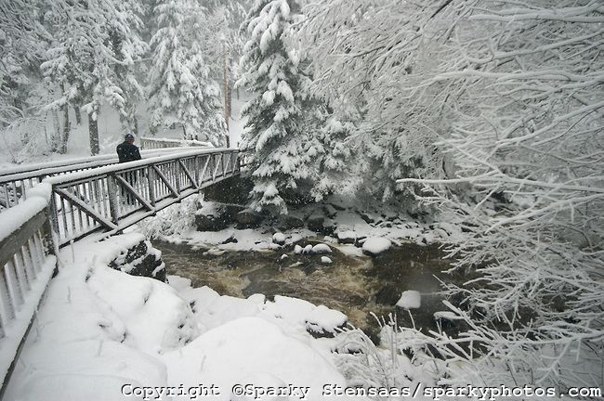

Winter Walk In Duluth, MN

Water
Of
Life

9 February 2020

W A T E R O F L I F E

Independent Christian Church—Conservative Lutheran Doctrine

Worship Service: 9:30 a.m. Bible Study: 10:45 a.m.

Larry Cooper, Pastor E-Mail address:
111 N. Ridge Road lcooper@wateroflife.cc
Coon Valley, WI 54623 Web Site:
www.wateroflife.cc

* * * * * * * * * * * * * * * * * * * * * * * * * * *

Sermon Text: Mark 12:35-37

David’s Son

* * * * * * * * * * * * * * * * * * * * * * * * * * *

Mark 12:35 And Jesus answered and said, while he taught in the temple, How say the scribes that Christ is the Son of David?
:36 For David himself said by the Holy Ghost, The LORD said to my Lord, Sit thou on my right hand, till I make thine enemies thy footstool.
:37 David therefore himself calleth him Lord; and whence is he then his son? And the common people heard him gladly.

Matthew 25:1-13

1 Then shall the kingdom of heaven be likened unto ten virgins, which took their lamps, and went forth to meet the bridegroom.
2 And five of them were wise, and five were foolish.
3 They that were foolish took their lamps, and took no oil with them:
4 But the wise took oil in their vessels with their lamps.
5 While the bridegroom tarried, they all slumbered and slept.
6 And at midnight there was a cry made, Behold, the bridegroom cometh; go ye out to meet him.
7 Then all those virgins arose, and trimmed their lamps.
8 And the foolish said unto the wise, Give us of your oil; for our lamps are gone out.
9 But the wise answered, saying, Not so; lest there be not enough for us and you: but go ye rather to them that sell, and buy for yourselves.
10 And while they went to buy, the bridegroom came; and they that were ready went in with him to the marriage: and the door was shut.
11 Afterward came also the other virgins, saying, Lord, Lord, open to us.
12 But he answered and said, Verily I say unto you, I know you not.
13 Watch therefore, for ye know neither the day nor the hour wherein the Son of man cometh.

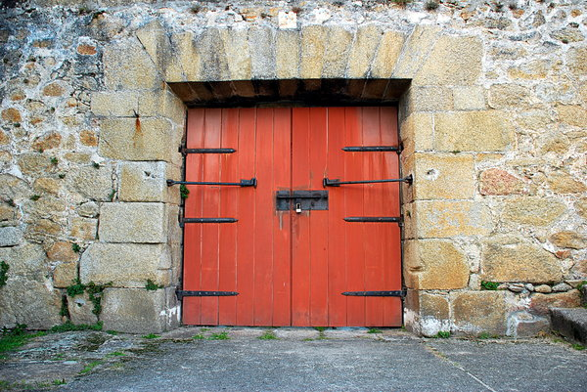

And The Door Was Shut

